
Name: Peta Harsha Vardhan Register No: 192311039
Subject: Machine Learning – Unit 2 (SDG Project)
1. Backpropagation for Predicting Sanitation Access in Slum Households
SDG: SDG 6 – Clean Water and Sanitation
1.1 Problem Statement
Millions of people in urban slums still live without a toilet, a sewer connection or a dependable water supply. Government surveys are slow and costly, so the households that need sanitation most are often identified late. A small neural network can learn from easy-to-collect household data and predict whether a household already has access to sanitation facilities, so that municipal bodies and NGOs can target toilets, water points and sewer lines where they are missing.
This assignment traces, step by step, how such a network learns. A simple 2-input, 1-hidden-layer network is taken, and one full forward pass and one full backward pass of backpropagation are worked out by hand with actual numbers. The same procedure is then repeated in NumPy over a whole dataset.
Objectives
- Predict whether a slum household has access to sanitation facilities (1 = has access, 0 = no access).
- Trace the forward pass of a 2-2-1 network and compute the prediction and the loss.
- Trace the backward pass, computing the gradient of the loss with respect to every weight and bias.
- Update the weights using gradient descent and show that the loss decreases.
- Identify under-served households so that SDG 6 (Target 6.2: access to adequate sanitation for all) can be pursued with better targeting.
1.2 Dataset
Dataset used: A synthetic slum-household dataset (1,500 records, 3 columns) generated with NumPy for demonstration, because real household survey data is restricted. The same pipeline applies to real data such as NFHS, Census sanitation tables or JMP (WHO/UNICEF) household surveys.
Features
Feature | Description
x1 = monthly_income | Estimated household monthly income (₹), scaled to 0–1 for the hand trace
x2 = water_access_score | Quality of water supply near the household (0 = none, 1 = reliable piped supply), 0–1
has_sanitation (target y) | 1 = household has access to a toilet or sanitation facility, 0 = no access

Target: has_sanitation → 1 = Has access, 0 = No access
Data Preparation
- Generated income and water-access values with NumPy and added random noise to the outcome, so the problem is realistic and not perfectly separable.
- Standardised both inputs (zero mean, unit variance) for training.
- Split into 80% training (1,200) and 20% testing (300) sets.
- Initialised weights with small random numbers and biases at zero.
1.3 ML Approach
This is a binary classification problem solved with a feed-forward neural network trained by backpropagation. The network has 2 input neurons, 1 hidden layer of 2 neurons and 1 output neuron. Sigmoid activation is used in the hidden and output layers, and the loss is the squared error E = ½ (y − ŷ)². Learning rate η = 0.5.
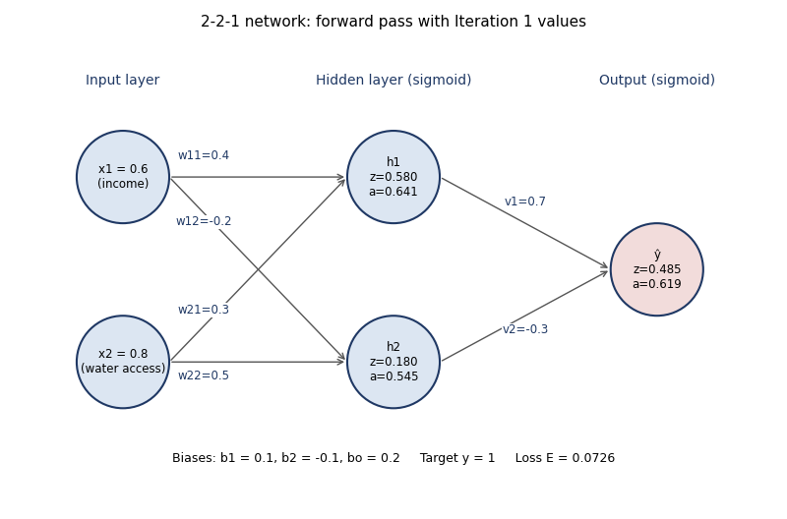
Figure 1: The 2-2-1 network with the initial weights and the forward-pass values for one household.
Notation
Symbol | Meaning
w11, w21 | Weights from x1 and x2 to hidden neuron h1 (b1 = bias of h1)
w12, w22 | Weights from x1 and x2 to hidden neuron h2 (b2 = bias of h2)
v1, v2, bo | Weights from h1, h2 to the output neuron, and the output bias
z, a | z = weighted sum (pre-activation), a = σ(z) = 1 / (1 + e^−z)
δ | Error signal at a neuron = ∂E/∂z

Workflow
Household data (x1, x2)
↓
Forward pass: inputs → hidden → output (ŷ)
↓
Loss: E = ½ (y − ŷ)²
↓
Backward pass: δ at output → δ at hidden → gradients
↓
Gradient-descent update of all weights and biases
↓
Repeat until loss is small → Prediction: has sanitation / no sanitation

1.4 Forward and Backward Pass Trace
Worked example: one household with x1 = 0.6 (moderate income), x2 = 0.8 (good water access) that actually has sanitation, so y = 1. Initial parameters: w11 = 0.4, w21 = 0.3, w12 = −0.2, w22 = 0.5, b1 = 0.1, b2 = −0.1, v1 = 0.7, v2 = −0.3, bo = 0.2.
Step 1: Forward pass
Neuron | Calculation | Result
Hidden h1 | z1 = w11·x1 + w21·x2 + b1 = 0.4(0.6) + 0.3(0.8) + 0.1 | z1 = 0.580
 | a1 = σ(0.580) | a1 = 0.6411
Hidden h2 | z2 = w12·x1 + w22·x2 + b2 = −0.2(0.6) + 0.5(0.8) − 0.1 | z2 = 0.180
 | a2 = σ(0.180) | a2 = 0.5449
Output | zo = v1·a1 + v2·a2 + bo = 0.7(0.6411) − 0.3(0.5449) + 0.2 | zo = 0.4853
 | ŷ = σ(0.4853) | ŷ = 0.6190
Loss | E = ½ (y − ŷ)² = ½ (1 − 0.6190)² | E = 0.0726

The network predicts a 61.9% chance of sanitation access, but the true value is 1, so the error is 0.381. Backpropagation will now push the weights so that the next prediction is higher.
Step 2: Backward pass – output layer
Quantity | Calculation | Result
∂E/∂ŷ | ŷ − y = 0.6190 − 1 | −0.3810
σ′(zo) | ŷ(1 − ŷ) = 0.6190 × 0.3810 | 0.2358
δo = ∂E/∂zo | (−0.3810) × 0.2358 | −0.0899
∂E/∂v1 | δo · a1 = −0.0899 × 0.6411 | −0.0576
∂E/∂v2 | δo · a2 = −0.0899 × 0.5449 | −0.0490
∂E/∂bo | δo × 1 | −0.0899

Step 3: Backward pass – hidden layer (chain rule)
The output error is sent back through the weights v1 and v2, then multiplied by the local slope σ′(z) = a(1 − a) of each hidden neuron.
Quantity | Calculation | Result
δ1 = ∂E/∂z1 | δo · v1 · a1(1 − a1) = −0.0899 × 0.7 × 0.2301 | −0.01447
δ2 = ∂E/∂z2 | δo · v2 · a2(1 − a2) = −0.0899 × (−0.3) × 0.2480 | +0.00668
∂E/∂w11 | δ1 · x1 = −0.01447 × 0.6 | −0.00868
∂E/∂w21 | δ1 · x2 = −0.01447 × 0.8 | −0.01158
∂E/∂w12 | δ2 · x1 = 0.00668 × 0.6 | +0.00401
∂E/∂w22 | δ2 · x2 = 0.00668 × 0.8 | +0.00535
∂E/∂b1, ∂E/∂b2 | δ1 and δ2 | −0.01447, +0.00668

Step 4: Weight update (η = 0.5)
Each parameter is updated with new = old − η × gradient.
Parameter | Calculation | Old | New
v1 | 0.7 − 0.5(−0.0576) | 0.7000 | 0.7288
v2 | −0.3 − 0.5(−0.0490) | −0.3000 | −0.2755
bo | 0.2 − 0.5(−0.0899) | 0.2000 | 0.2449
w11 | 0.4 − 0.5(−0.00868) | 0.4000 | 0.4043
w21 | 0.3 − 0.5(−0.01158) | 0.3000 | 0.3058
w12 | −0.2 − 0.5(0.00401) | −0.2000 | −0.2020
w22 | 0.5 − 0.5(0.00535) | 0.5000 | 0.4973
b1 | 0.1 − 0.5(−0.01447) | 0.1000 | 0.1072
b2 | −0.1 − 0.5(0.00668) | −0.1000 | −0.1033

Step 5: Check – forward pass again with the new weights
 | Iteration 1 | Iteration 2
Output ŷ | 0.6190 | 0.6376
Loss E | 0.0726 | 0.0657
Output error δo | −0.0899 | −0.0837

The prediction moved from 0.6190 towards the target 1 and the loss fell from 0.0726 to 0.0657 after a single update, which confirms that the gradients point in the right direction. Repeating the forward pass, backward pass and update for many households and many epochs drives the loss down further.
1.5 NumPy Implementation
The same two passes written in NumPy. The first block reproduces the hand trace; the second trains the network on all training households.
import numpy as np
sig = lambda z: 1 / (1 + np.exp(-z))

# ---- one household (hand trace) ----
x = np.array([0.6, 0.8]); y = 1.0; lr = 0.5
W1 = np.array([[0.4, -0.2], # x1 -> h1, h2
[0.3, 0.5]]) # x2 -> h1, h2
b1 = np.array([0.1, -0.1])
W2 = np.array([0.7, -0.3]); b2 = 0.2

# forward pass
z1 = x @ W1 + b1; a1 = sig(z1)
zo = a1 @ W2 + b2; o = sig(zo)
E = 0.5 * (y - o) ** 2

# backward pass
d_o = (o - y) * o * (1 - o) # delta at output
gW2 = d_o * a1; gb2 = d_o
d_h = d_o * W2 * a1 * (1 - a1) # delta at hidden
gW1 = np.outer(x, d_h); gb1 = d_h

# gradient-descent update
W2 -= lr * gW2; b2 -= lr * gb2
W1 -= lr * gW1; b1 -= lr * gb1
print(round(E, 4), round(o, 4)) # 0.0726 0.6190

# ---- full training on the dataset ----
for epoch in range(1000):
h = sig(Xtr @ W1 + b1); o = sig(h @ W2 + b2)
d_o = (o - ytr) * o * (1 - o) / len(ytr)
d_h = np.outer(d_o, W2) * h * (1 - h)
W2 -= lr * (h.T @ d_o); b2 -= lr * d_o.sum()
W1 -= lr * (Xtr.T @ d_h); b1 -= lr * d_h.sum(0)

Key findings from the data
- Class distribution: 764 households have sanitation and 736 do not (about 51% access), so the classes are well balanced.
- Sanitation access rises sharply with income: 17.7% in low-income, 45.2% in middle-income and 74.7% in high-income households.
- Water access and sanitation go together: 25.2% access where the water-access score is low, rising to 76.4% where it is high.
- Mean monthly income in the sample is about ₹8,964.
1.6 Visualization
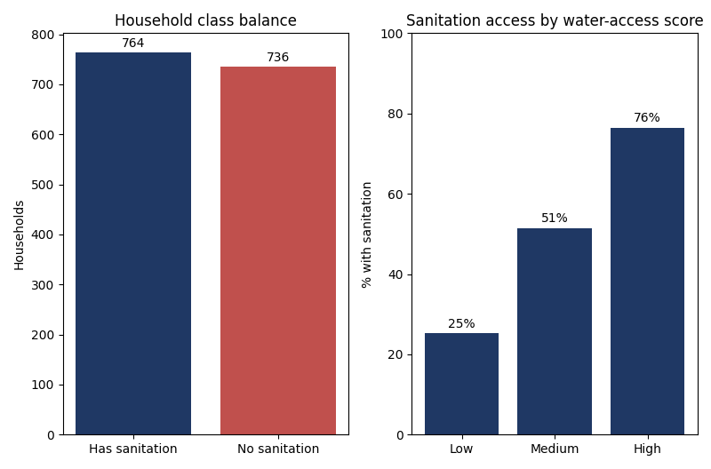
Figure 2: Class balance, and sanitation access increases with water-access score.
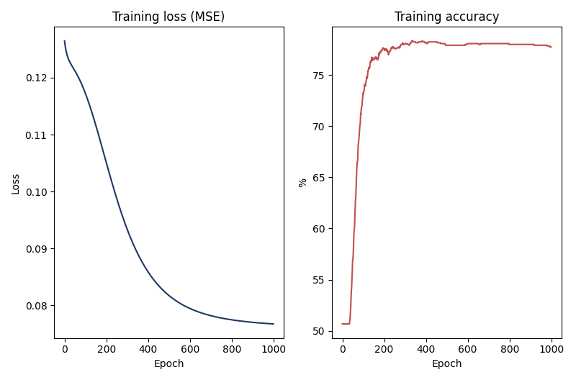
Figure 3: Training loss falls and accuracy rises as backpropagation updates the weights.
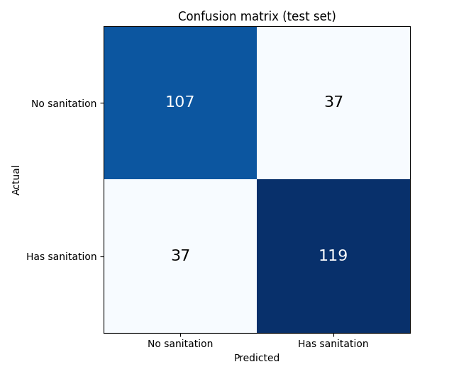
Figure 4: Confusion matrix of the trained network on the 300-household test set.
Interpretation: The loss decreases steadily, showing that the repeated forward pass, backward pass and weight update are working. Households with low income and poor water access are the ones the model most often flags as lacking sanitation, which is where interventions are needed first.
1.7 Expected Outcome
The trained network classifies a household as likely to have or to lack sanitation access. Results on the 300-household test set:
Model | Accuracy | Precision | Recall | F1-score | ROC-AUC
2-2-1 Neural Network (backpropagation) | 0.753 | 0.763 | 0.763 | 0.763 | 0.840

The confusion matrix gives TN = 107, FP = 37, FN = 37, TP = 119: the network correctly identifies 107 of 144 households without sanitation and 119 of 156 households with sanitation. Training loss fell from 0.126 to 0.077 over 1,000 epochs. The 2-neuron hidden layer is deliberately small so that every number can be traced by hand.
Note: The data is synthetic with deliberately noisy outcomes, so the scores are moderate. They demonstrate the method, not real-world performance. On real survey data the model would need validation before any deployment.
1.8 Innovation and SDG
The work supports SDG 6 – Clean Water and Sanitation (Target 6.2: access to adequate and equitable sanitation and hygiene for all) and also contributes to SDG 3 (Good Health and Well-being) and SDG 11 (Sustainable Cities and Communities).
How neural networks help sanitation planning
- Targeting: ranks slum households by likelihood of lacking sanitation so toilets and sewer lines go where they are needed first.
- Lower survey cost: predicts from a few cheap indicators, so full door-to-door surveys are needed less often.
- Disease prevention: better sanitation reduces diarrhoea, cholera and typhoid, protecting children in particular.
- Scalable: the same network can take more inputs (toilet density, drainage, population) as data becomes available.
- Monitoring: retraining on new data tracks progress towards Target 6.2 over time.
Advantages
- Simple network whose every step can be explained and verified
- Learns non-linear relations between income, water access and sanitation
- Fast to train and cheap to run
Limitations
Predictions depend on the quality of the input data, and survey data from informal settlements is often incomplete or outdated. A 2-input model ignores many factors such as land tenure, sewer layout and community behaviour. Sigmoid units can learn slowly when gradients become very small, and a wrong prediction can send aid away from a deserving household, so the output should support, not replace, field verification.
Conclusion
Tracing backpropagation by hand shows exactly how a neural network learns: the forward pass produces a prediction and an error, and the backward pass uses the chain rule to assign blame to every weight and bias. In the worked example, one update reduced the loss from 0.0726 to 0.0657, and training on the full dataset reached 75.3% test accuracy for predicting sanitation access. Used as a decision-support tool and checked against field data, such a model can help direct resources to the slum households that need toilets and clean water most, supporting SDG 6 – Clean Water and Sanitation.

